**Etude 1: Perceptron-P**

**PART ONE (Notes/Photos):**

* When I click reset and the black button, the lights stop blinking for 1 second.
* When I press both buttons longer, the light still blinks
* 5 x 220 OHM resistors and 1 x 1K OHM resistor
* Need to verify > upload Arduino program and plug the blue USB cord only

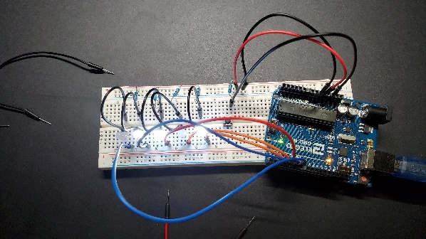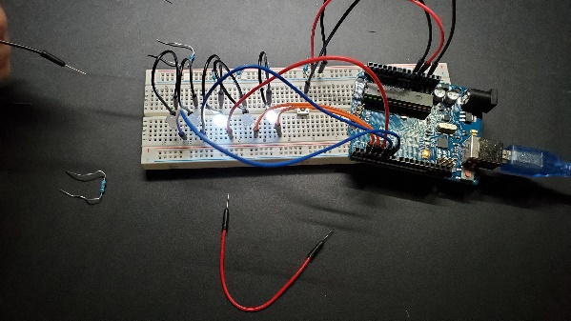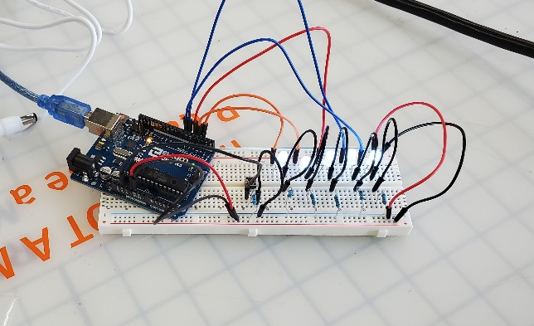

**PART TWO:**

Determine the feature(s) that distinguish these two circuits – what makes them different and why?

The Built Circuit contains six resistors and 16 wires meanwhile, the Alternate Circuit has two resistors and 20 wires. It makes them different because instead of using resistors to transfer the power to each LED light, the Alternate Circuit uses wires to transfer power coming from the first 220 OHM resistor on the left.

Which of the circuits presented would be a more reliable circuit – Why?

The Built Circuit would be a more reliable circuit because there are more resistors than the Alternative Circuit. It is also a mixed parallel and series circuit. The more resistors there are in a parallel circuit, the more branches there are for the current to flow, it increases the current’s rate and lowers the resistance.

“The electrical current flowing through a fixed linear resistance is directly proportional to the voltage applied across it, and also inversely proportional the resistance”.

What is occurring with the V/I/R in the area(s) that you have discerned as important?

V: voltage / I: Current / R: Resistance

The current is constant and transfer the 5V power to the LED lights. The 5 x 220 OHM resistors are placed to transfer the equivalent power to the LED lights on the Built Circuit.

**PART THREE:**

1. Explain, the purpose of the highlighted area contained within the red rectangle… What does it do?

The black button has the same purpose as the reset button. It stops the current for one second and restart right after making the light stop blinking for a second. The 1K OHM resistor is to maintain 5V of current to go through the switch without losing power. The wires are to connect the breadboard to the Arduino program, to connect the reset function and link another function that breaks the current.

b) Why/how is the functionality implemented (electrically) – Use appropriate terminology?

* The 1K OHM resistor is higher than the voltage to let the current circulate at a higher rate from the source.
* The wires are the nodes that transfers the 5V of power to the Arduino.
* The black button is a momentary switch that breaks the circuit for one second.

**PART FOUR:**

(Images from the folder attached)